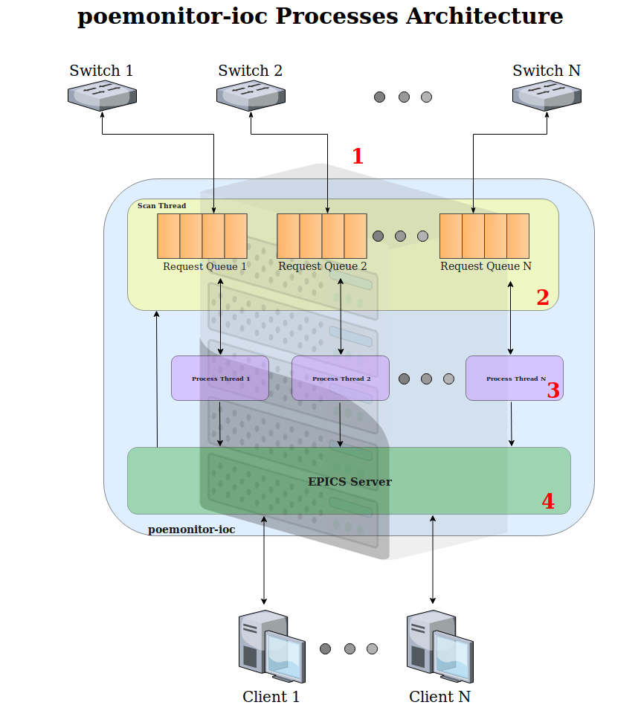

1. **EPICS Driver Module**
   * Creates one request queue for each switch configured to be monitored on poemonitor.config file
   * Starts scan thread and one process thread for each request queue created before
2. **SCAN THREAD**
   * Periodically inserts scan requests on each request queue
3. **PROCESS THREAD**
   * Get requests from the respective request queue and process it
   * Login on switch’s REST API and connection failure resilience methods
4. **EPICS Server**
   * Creates the interface for processing clients requests and, using EPICS driver module functions, inserts write requests on request queues